Week 11: System Integration

Name : Swayam Rudrawar

Objective:
Integrate the machine learning model, intelligent detection dashboard, event logging and Telegram cloud notification into one complete Smart Light Monitoring System.

Introduction:
Week 11 combines all previously developed modules into a single Streamlit application capable of replaying live sensor data, classifying light intensity, detecting anomalies, logging events and sending Telegram notifications.

Hardware Components:
Component | Purpose
Computer/Laptop | Runs integrated application
Recorded Dataset | Simulated live sensor
Internet | Telegram alerts
Mobile Phone | Receives notifications

Software Components:
- Python
- Streamlit
- Scikit-learn
- Pandas
- Plotly
- Joblib
- Requests
- Telegram Bot API
- VS Code

System Architecture:
Recorded Dataset → Preprocessing → Decision Tree Model → Light Classification → Threshold Detection → Telegram Alert + Event Logging → Streamlit Dashboard

Working Principle:
- Load model and dataset.
- Replay Lux readings as live data.
- Predict Bright, Dark or Dim.
- Compare Lux with threshold.
- Detect anomalies.
- Send Telegram alert.
- Update dashboard and event history.

Integrated Modules:
- Sensor Data Simulation
- Decision Tree Prediction
- Intelligent Detection
- Telegram Alert
- Dashboard
- Event Logging

Code Optimization:
- Modular functions.
- Model loaded once.
- Lightweight Decision Tree.
- Adjustable refresh interval.
- Minimal feature set.

Error Handling:
- Missing model.
- Missing dataset.
- Missing columns.
- Telegram API failure.
- Network exceptions.

Results:
The integrated system successfully monitored light intensity, detected anomalies, logged events and generated Telegram cloud notifications.
Figure 1. Integrated Dashboard
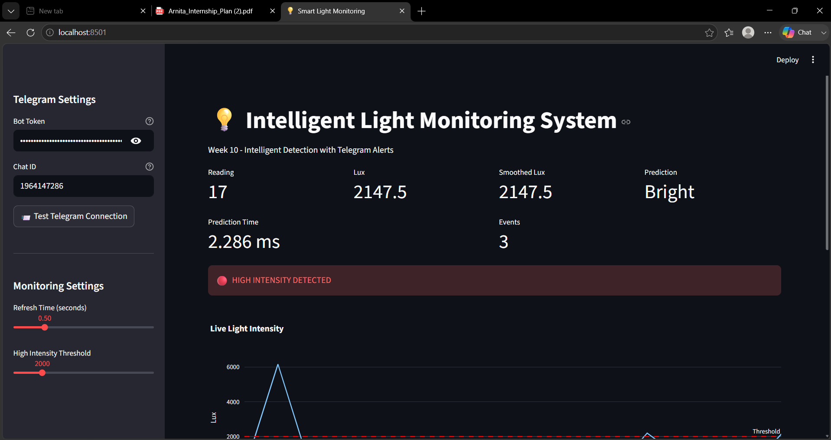

Figure 2. Event History
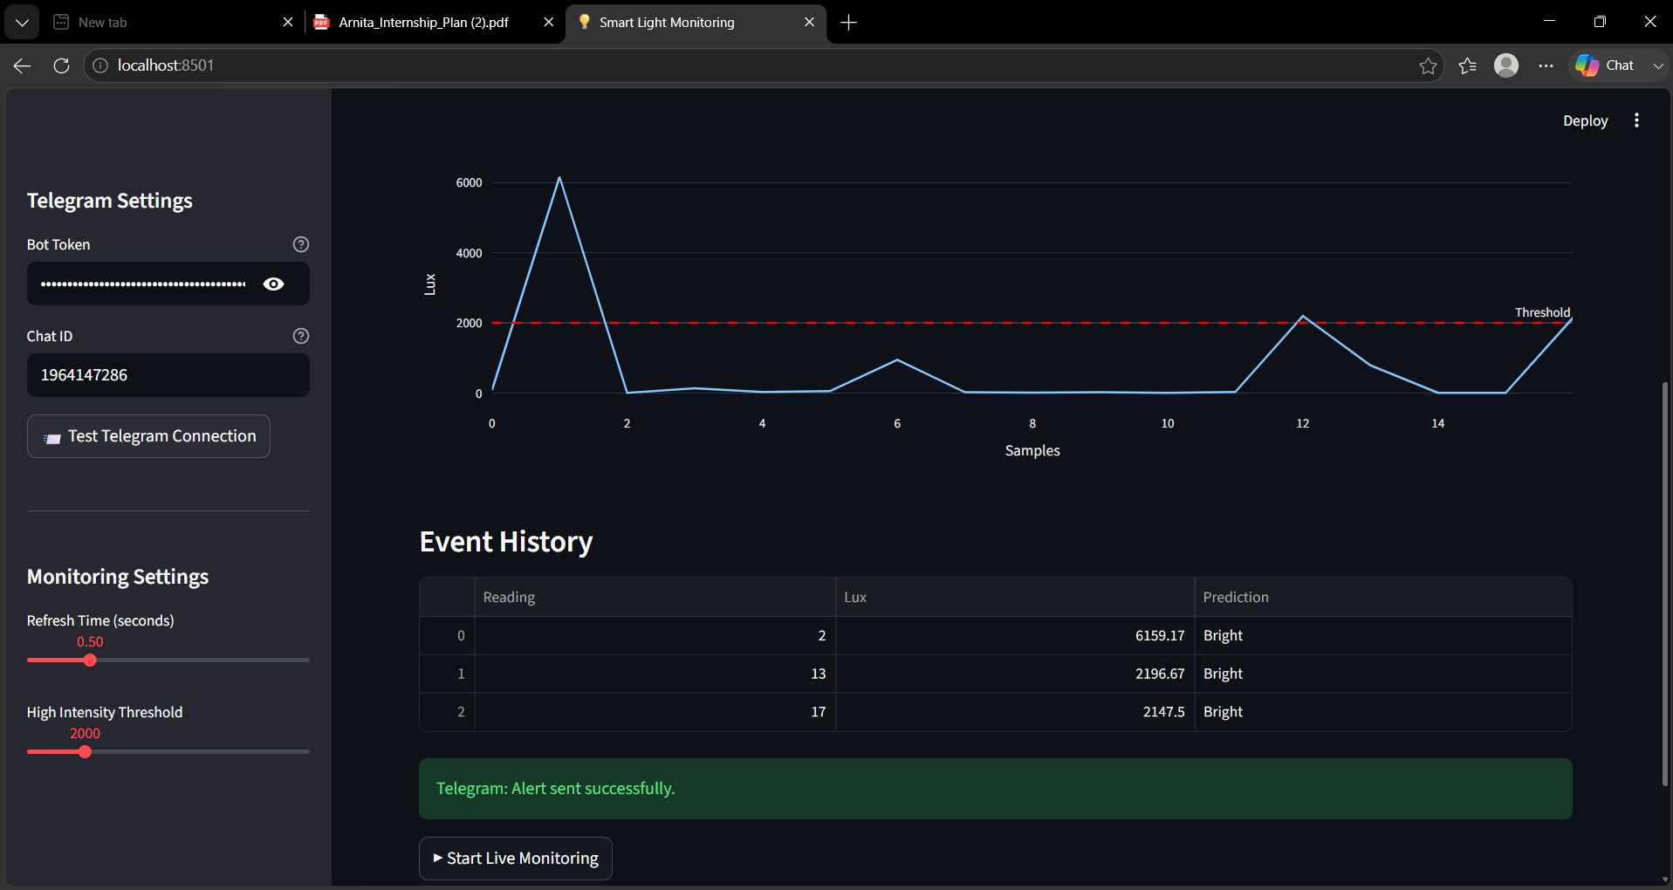
Figure 3. Telegram Notification
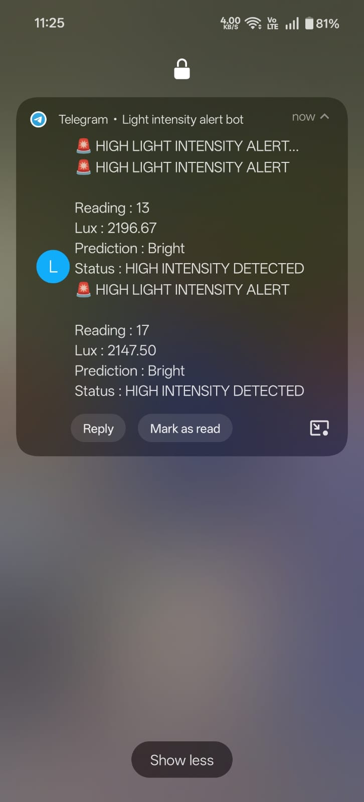
Figure 4. Line graph visualization (Bright)
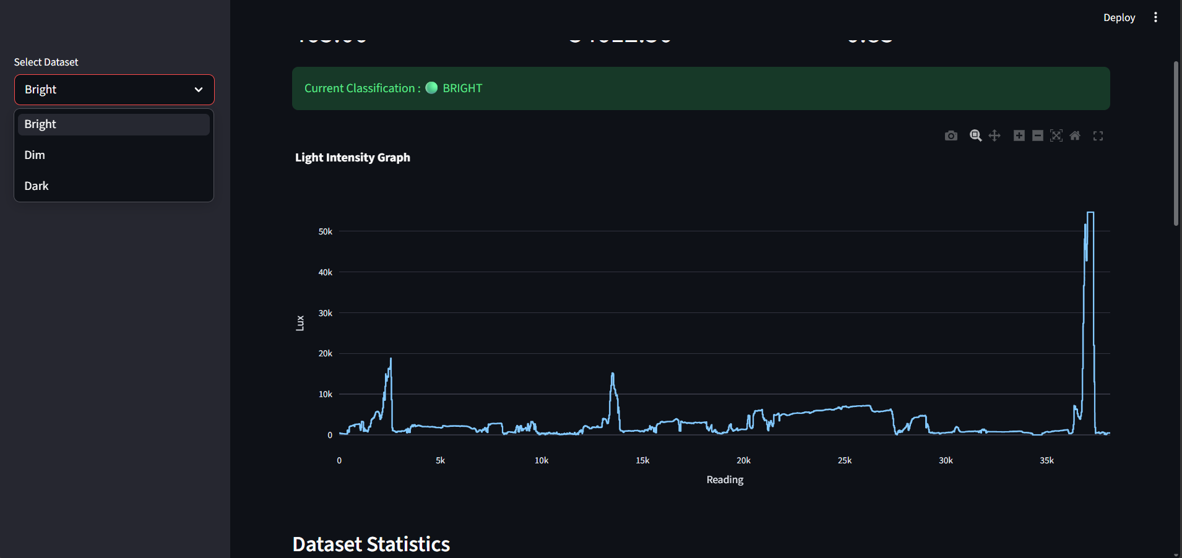

Challenges Faced:
- Integrating all modules.
- Telegram API debugging.
- Real-time synchronization.
- Avoiding duplicate alerts.

Conclusion:
The Week 11 objective was successfully achieved by integrating machine learning prediction, intelligent detection, dashboard visualization, event logging and Telegram cloud alerts into one complete Smart Monitoring System.

